A

PROJECT ON “PC ASSISTAT NAMED ……………………..”

INDEX

1.INTRODUCTION……………………………………………………………01-02

2.BACKGROUND ERROR………………………………………………….03-

3.PROJECT DESCRIPTION………………………………………………..

4. RESULT

5.RESARCH PAPER

6.

**INTRODUCTION**

Nowadays the Mobile Technology is being very famous for the User Experience, because it is very easy to access the applications and services from anywhere of your Geo-location. Android, Apple, Windows, Blackberry, etc. are various famous and commonly used Mobile Operating Systems. All the Operating Systems provides plenty of applications and services for users. For an instance, the Contacts Applications is used to store the contact details of the user's contact and also helps user to connect a call or send an SMS to other person using the contents stored in this application. We can get similar types of application all around the world via Apple Store, Play Store, etc. All this features gives birth to various kinds of sensors or functionalities to be implemented in the mobile devices. The Most famous application of iPhone is “SIRI” which helps the end user to communicate end user to mobile with voice and it also responds to the voice commands of the user. Same kind of application is also developed by the Google that is“Google Voice Search” which is used for in Android Phones. But this Application mostly works with Internet Connections. But our Proposed System has capability to work with and without Internet Connectivity. It’s named as Personal Assistant with Voice Recognition Intelligence, which takes the user input in form of voice or text and process it and returns the output in various forms like action to be performed or the search result is dictated to the end user. Introduction:-Voice command control has always been an area of great interest. Since a longtime programmers are working on it but till date a full fleged model that understands natural language is not available. Models like apple’s siri, Amazon’s Alexa, IBM’s Watson, Microsoft’s Cortana etc are available and are successful to a huge level but their applications and varity of actions preformed are very limited. Some of them are just limited to devices like mobile phones and tabs while others do not have the varity of applications. A requirment of a voice assistant is always felt by the users. Under this project we have tried to combine all the applications and functions and create a well-equiped and capable assistant. In future on basis of this project we would tried to create a complete assistant who would not only perform tasks on pc but would be capable of performing all odd jobs which can be controlled using electricity. Its working environment would move from our personal computer to the real world.

BACKGROUND AND HISTORY

History of Voice Recognition

Voice recognition is the ability of a machine or program to identify words and phrases in spoken language and convert them to a machine readable formate……. Designing a machine that mimics human behavior, especially the capability of speaking and responding to it, has intrigued engineers and scientists for centuries.

Speech technologies have witnessed a dramatic transformation, from what started as a speech machine using resonance tubes to Graham Bell’s first recording device to Dictaphone and the first voice synthesizer, Voic Operating Demonstrator (VODER) to today’s smart virtual assistants like Apple’s Siri or Amazon’s Alexa . Thanks to the advancements in AI, Voice recognition technology is gaining popularity. According to a recent U.S. Cellular survey, 36% of smartphone owners use a virtual assistant daily and 30% use smart home technology daily. This connectivity is expected to increase with the number of devices and sensors predicted to rise 200% to 46 billion by 2021.

The idea is to transform recorded audio into a sequence of words, as an alternative to typing on the keyboard. From helping people with physical disabilities, transcription of interviews, learning a new language or accessing a file via voice commands, speech recognition finds use in a number of applications. Voice recognition systems facilitate the interaction with technology, enabling hands-free requests.

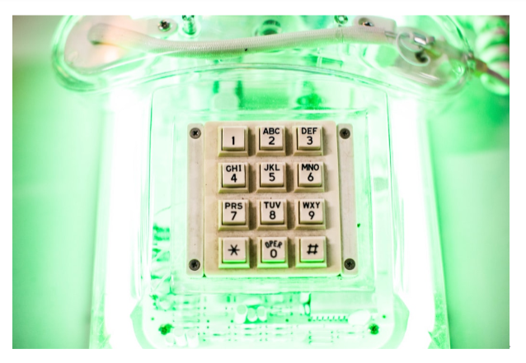

From 1952 to today :

The earliest voice recognition technologies could only comprehend digits. Audrey system, built by Bell Labs in 1952 considered to be the first speech recognition device, recognised only ten digits spoken by a single voice. This was followed by the Shoebox machine, developed by IBM in 1962, which could recognise 16 English words, 10 digits and 6 arithmetic commands. The U.S. Department of Defence made great contributions towards the development speech recognition systems. From 1971 to 1976, it funded the DARPA SUR (Speech Understanding Research) program, which led to the development of Harpy by Carnegie Mellon that could comprehend 1011 words. At around the same time, the first commercial speech recognition company, Threshold Technology was founded and Bell Labs introduced a system that could interpret multiple people’s voices. In

1978, Texas Instruments introduced Speak &amp; Spell, which was a milestone in speech development because of its use of speech chip, leading to more human-like digital synthesis sound. The development of hidden Markov model, which considered the probability of unknown sounds using statistics proved to be a major breakthrough, it even entered the home, in the form of Worlds of Wonder’s Julie doll.

PROJECT DESCRIPTION

Software Requirements:-

Hardware Requirements:-

Project Module Design:-

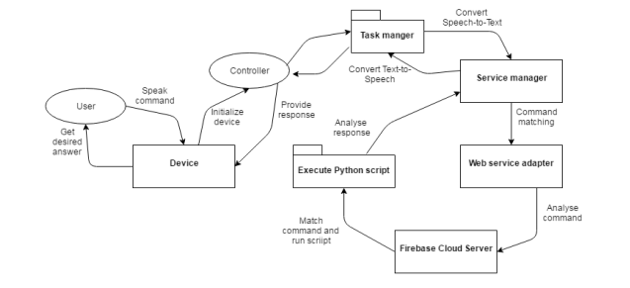

Use Case Diagram:-

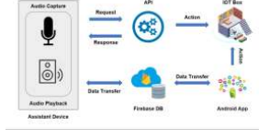

Block Diagram/Process Dig.:-

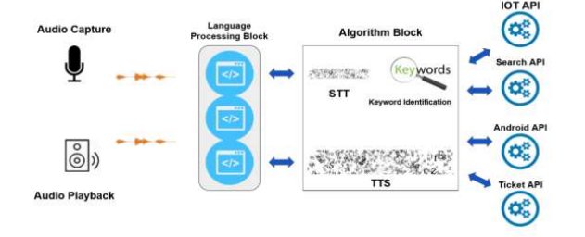

RESULT

**RESARCH PAPER**

**Personal Assistant with Voice Recognition Intelligence**

**Abstract**

The Most famous application of iPhone is “SIRI” which helps the end user to communicate end user mobile with voice and it also responds to the voice commands of the user. Same kind of application is also developed by the Google that is “Google Voice Search” which is used for in Android Phones. But this

Application mostly works with Internet Connections. But our Proposed System has capability to work with and without Internet Connectivity. It is named as Personal Assistant withVoice Recognition Intelligence, which takes the user input in form of voice or text and process it and returns the output in various forms like action to be performed or the search result is dictated to the end user. In addition, this proposed system can change the way of interactions between end user and the mobile devices. The system is being designed in such a way that all the services provided by the mobile devices are accessible by the end user on the user's voice commands. Keywords: SIRI, Google Voice Search, Mobile Device,Internet

**Introduction**

Nowadays the Mobile Technology is being very famous for the User Experience, because it is very easy to access the applications and services from anywhere of your Geo-location. Android, Apple, Windows, Blackberry, etc. are various famous and commonly used Mobile Operating Systems. All the Operating Systems provides plenty of applications and services for users. For an instance, the Contacts Applications is used to store the contact details of the user's contact and also helps user to connect a call or send an SMS to other person using the contents stored in this application. We can get similar types of application all around the world via Apple Store, Play Store, etc. All this features gives birth to various kinds of sensors or functionalities to be implemented in the mobile devices. The Most famous application of iPhone is “SIRI” which helps the end user to communicate end user to mobile with voice and it also responds to the voice commands of the user. Same kind of application is also developed by the Google that is “Google Voice Search” which is used for in Android Phones. But this Application mostly works with Internet Connections. But our Proposed System has capability to work with and without Internet Connectivity. It’s named as Personal Assistant with Voice Recognition Intelligence, which takes the user input in form of voice or text and process it and returns the output in various forms like action to be performed or the search result is dictated to the end user.

**Literature Survey**

Speech recognition has a long history with several waves of major innovations. Speech recognition for dictation, search, and voice commands has become a standard feature on smartphones and wearable devices. Design of a compact large vocabulary speech recognition system that can run efficiently on mobile devices, accurately and with low latency. [1] This is achieved by using a CTC- based LSTM acoustic model which predicts context- independent phones and is compressed to a tenth of its original size using a combination of SVD-based compression and quantization. Quantized deep neural networks (DNNs) and on-the-fly language model rescoring to achieve real-time performance on modern smartphones.

The ASR and Search components perform speech recognition and search tasks. In addition to ASR and Search, we also integrate a query parsing module between ASR and Search for a number of reasons. [3] Set of techniques for improving the performance of automated voice search services intended for mobile users accessing these services over a range of portable devices. Voice search is implemented as a two stage search procedure where string candidates generated by an automatic speech recognition (ASR) system are re-scored in order to identify the best matching entry from a potentially very large application specific database. Study provides a good example of how additional domain specific knowledge sources can be used with a domain independent ASR system to facilitate voice access to online search indices. As more data becomes available for a given speech recognition task, the natural way to improve recognition 416accuracy is to train larger acoustic models. There are a non- parametric empirical model that exploits abundant trainingdata to directly learn pronunciation variation. Interpolating the empirical model with a parametric model yields the best performance, with a relative improvement of 5.2% in WER over the baseline. [2] There are a number of ways in which this work could be extended. First, closer integration with acoustic model training is likely to yield sharper distributions and a tighter fit to the data. Second, estimating word pronunciation co-occurrence counts in semi-supervised fashion (e.g. through word recognition instead of forced alignment) would broaden its applicability to a wide range of speech genres and tasks.

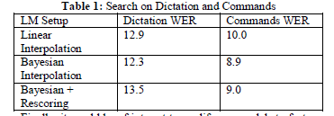

Table 1: Search on Dictation and Commands

Finally, it would be of interest to modify our models to factor out the distinct phenomena that affect pronunciation (e.g. accent, dialect, recognition errors). This paper focuses on the development and advances in automatic speech recognition for the AT&T Speak4it R voice search application [5]. With Speak4it as real-life example, we show the effectiveness of acoustic model (AM) and language model (LM) estimation (adaptation and training) on relatively small amounts ofapplication field-data. Methods are investigated for identifying the most likely database entry associated with the decoded utterance. An experimental study is presented describing the characteristics of actual user utterances obtained from a prototype voice search service. The impact of these methods on word error rate is presented.

**Proposed Architecture**

PARI has various branches of the services, but the main feature of PARI is Voice Recognition Engine which has an ability to work without internet connection i.e. Offline Voice Recognition.

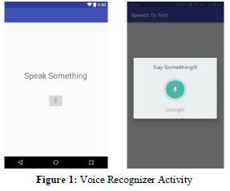

This Voice Recognizer works offline and performs various operations as per the user commands and requirements. This is the first activity that’s opens whenever we starts PARI and it directly can be opened by pressing Power Button of the mobile devices.

This feature is specially design for Blind Persons who wish to use the Android Smart Phones but are unable to connect this technology. Also Native user who barely knows to unlock their smart phones can easily open this application and using voice commands in their local languages as per need. PARI responds to basic commands like, Open Applications, Close Applications, Connect Calls To respective person/contacts, send text SMS to respective person or contact, Capture Photos from camera (Front Camera/ Back Camera), Add/Delete/Update Contacts, Run any media file, Start various services like Hotspot, Wi-Fi, Bluetooth, and various Services from the respective Notification Panel. All this can be performed on the voice commands of the end user without internet connectivity. Operations such as Browsing or Searching for any topic, using Applications that need internet connections example “Send message to ABC, Hi I’m PQR sending message to you. Using WhatsApp”. All these basic operations are performed by the voice commands of the end user. Google did quietly enable offline recognition in that Search update, but there is no API or additional parameters available within the Speech Reconginzer Class. The functionality is available with no additional coding, however the user’s device will need to be configured correctly for it to begin working and this is where the problem. Also, Google have restricted certain Jelly Bean devices from using the offline recognition due to hardware constraints. Which devices this applies to is not documented, in fact, nothing is documented, so configuring the capabilities for the user has proved to be a matter of trial and error.

Steps to Start Offline Voice Recognizer in Latest Android

Smart Phones-

1. Make sure the default Android Voice Recognizer is set to

Google

2. Uninstall any offline recognition files you already have installed from the Google

Voice Search Settings

3. Go to your Android Application Settings and see if you can uninstall the updates for the Google Search and Google Voice

Search applications.

4. If you can't do the above, go to the Play Store see if you have the option there.

5. Reboot (if you achieved 2, 3 or 4)

6. Update Google Search and Google Voice Search from the

Play Store (if you achieved 3 or 4 or if an update is available anyway).

7. Reboot (if you achieved 6)

8. Install English UK offline language files

9. Reboot

10. Use Utter with a connection

11. Switch to aero plane mode and give it a try

12. Once it is working, the offline recognition of other languages, such as English US should start working too.

Language is not a Barrier for PARI to understand the user voice commands for performing respective operations. Hence PARI uses its Intelligence to store the voice command detected by the end user with respect to the Default Commands stored in PARI.

**Extra Features**

We have also added some extra features. These are:

1. Sync up your storage

Your computer has local storage, as does your phone – two separate, unconnected virtual vats of space. But with a clever cloud-embracing app and a few minutes of configuration, the devices' drives can act as if they're one

The Android app FolderSync allows you to sync up storage between your desktop PC and Android smartphone. The secret resides in FolderSync, an Android utility that costs a mere (There's a free version, but it's peppered with ads and offers

limited functionality.) FolderSync works with a ton of cloud storage providers, including Amazon, Box, Dropbox, Google Drive, and OneDrive. As long as the provider you select offers a companion program on the PC side (all of the ones I mentioned do), you'll be good to go. To get everything up and running, first install the app on your phone and follow the prompts to connect it to the cloud storage service of your choice. Set up "pairs" for any folders you want to keep linked with your computer -- a folder containing your documents or downloads, for instance – and create new folders in your cloud storage to match. Be sure to set the pair to use two-way sync. You can either opt to sync instantly, if you want everything to be kept up-to-date at all times, or you can go for a more battery-friendly setup like syncing once a day if you don't mind a little bit of latency. Now install the desktop app for whatever cloud service you're using. Open the app, find the paired folder you created, and get it ready for use. If you paired a Documents folder, for example, you might place a shortcut on your desktop and dump all of your existing documents into it. Then treat that folder as if it were a regular local resource. Anything you do in it will be saved onto your hard drive and synced into the cloud, where it'll automatically find its way onto your Android device. Any changes on your phone will make their way back to your computer in the same manner.

2. Find and secure your phone

Can't find your phone in its usual place between couch cushions? Or, worse, get home from a day of travel only to

realize you lost your device somewhere along the way? No

need to panic: Your computer can tell you exactly where your

mobile buddy is. It can even remotely lock it down and erase

it if need be.

All you have to do is get on your computer (or any computer,

really), navigate togoogle.com in the browser, and type "Find

my phone" into the search box. (You'll have to sign into Google first -- which you'll probably want to do in an incognito window if it isn't your own PC.) Within seconds, Google will give you a detailed map showing your smartphone's last logged location. Clicking on it will bring up the full Android Device Manager interface, where you'll find options to ring, lock, or fully erase your phone right then and there.

There's one catch: Your phone has to be configuredbeforehand to allow all of that to happen. Take two minutes right now, while your phone is safe and sound, and open up the app called Google Settings on your device. (Note that we’re talking about Google Settings, which isn’t the same as your regular system settings.) Head into the Security menu and make sure both "Remotely locate this device" and "Allow remote lock and erase" are activated. Now take a deep breath, relax, and think of something else to worry about.

3. Access your entire computer from your phone

We couldn't talk about connecting your computer with your Android phone without mentioning the most direct connection of all: Being able to access yourentire computer from your smartphone's screen. Thanks to Google's free Chrome Remote Desktop app, it's easier than ever to do.

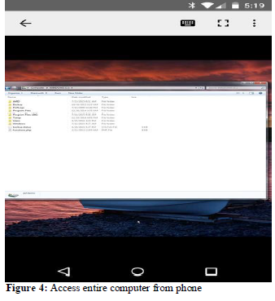

Accessing your desktop from your phone is easy, thanks to Chrome Remote Desktop. First, get the app on your phone and put the companion desktop appon your computer. (The desktop app will work on any platform where the Chrome browser can run.) Then pull up the Android app the next time you need to hop onto your computer remotely. You'll be able to move around your desktop, manipulate files, and even run programs from the palm of your hand

**Conclusion**

PARI is Designed to help Native and especially for Blind persons which works on their Voice Commands. PARI also has the capability of recognizing the voice commands without internet connection. PARI has various functionalities of mobile devices like network connection and managing various applications on just the voice commands. Contains key features like Voice Pattern Detection, Keyword Learning, etc. which helpful for end user to use various functionalities and services of the mobile devices. Hence, PARI is language barrier independent which actively responds to user’s voice commands faster than the Online Voice Search applications.

References

[1] “Accurate and compact large vocabulary speech recognition on mobile devices,” in INTERSPEECH. 2013, pp. 662–665, ISCA.

[2] “Connectionist temporal classification: Labelling unsegmented sequence data with recurrent neural networks,” in ICML, 2006, pp. 369–376.

[3] “Lattice-based optimization of sequence classification criteria for neural-network acoustic modeling”.

[4] “Language modeling for What-with Where on GOOG- 411,” Proc. of INTERSPEECH, 2009.

[5] “DFirect construction of compact context-dependency transducers from data,” Proc. of INTERSPEECH, pp. 218–221, 2010.

[6] “Automatic question generation for decision

SCREEN SHOTS